Z - Transform

EXPERIMENT - 9

CODE: -

clc

clear all

syms n z F f(n)

a=input('Enter the coefficient of f(n+2):');

b=input('Enter the coefficient of f(n+1):');

c=input('Enter the coefficient of f(n):');

G=input('Enter the RHS function:');

d=input('Enter the value of f(0):');

e=input('Enter the value of f(1):');

eq1=a\*str2sym('f(n+2)')+b\*str2sym('f(n+1)')+c\*str2sym('f(n)')-G;

eq2=ztrans(eq1);

eq3=subs(eq2,{ztrans(f(n), n, z),f(0),f(1)},{F,d,e});

eq4=collect(eq3,F);

F=solve(eq4,F);

f=simplify(iztrans(F));

disp('Solution of the difference equation is given by:')

disp(f)

m=0:10;

f1=subs(f,n,m);

stem(f1)

Input 1: -

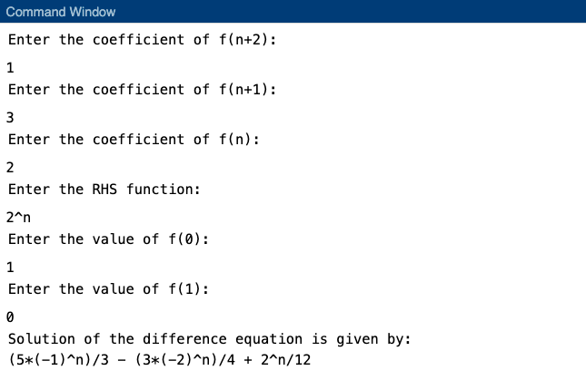

Graph: -

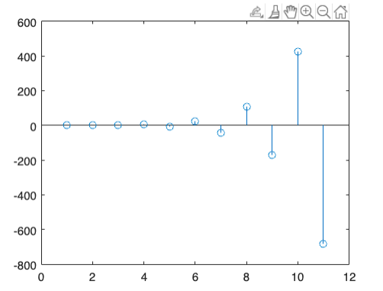

Input 2: -

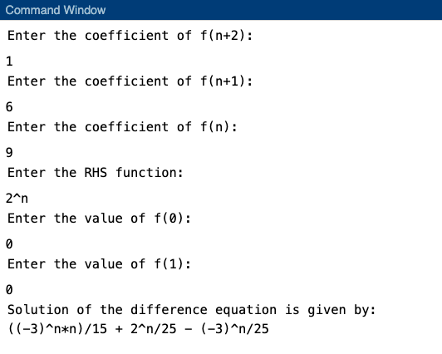

Graph: -

